Google Workspace User Manual
Please contact Paula or Barry for your member id
Home-screen name: EPGC Workspace and email
URL Address: [https://member.elparaisogolfclub.com/](https://member.elparaisogolfclub.com/)

---

Save EPGC Workspace and email

Open this address once, then save it so you do not have to type it again:

https://member.elparaisogolfclub.com/

On a phone or iPad, Add to Home Screen is best.
You get an icon named EPGC Workspace and email

---

iPhone (Safari)

**Bookmark**
1. Open Safari and go to **https://member.elparaisogolfclub.com/**
2. Tap **Share** (square with an arrow pointing up).
3. Tap **Add Bookmark**.
4. Tap **Save**.

**Home Screen icon (recommended)**
1. Open the page in Safari.
2. Tap **Share**.
3. Tap **Add to Home Screen**.
4. Name it **EPGC Workspace and email** and tap **Add**.

iPhone with Chrome
1. Open the page in Chrome.
2. Tap the **star**, or **⋮** → **Bookmark**.
3. For an icon: **⋮** → **Share** → **Add to Home Screen**, name it **EPGC Workspace and email**.

---

iPad (Safari)

1. Open **https://member.elparaisogolfclub.com/** in Safari.
2. Tap **Share**.
3. **Add Bookmark**, or **Add to Home Screen** and name it **EPGC Workspace and email**.

In Chrome: tap the **star**, or **⋮** → **Bookmark**.

---

Android (Chrome)

**Bookmark**
1. Open Chrome and go to **https://member.elparaisogolfclub.com/**
2. Tap the **star**, or **⋮** → **Bookmark**.

**Home Screen icon (recommended)**
1. Open the page in Chrome.
2. Tap **⋮** → **Add to Home screen**.
3. Name it **EPGC Workspace and email** and tap **Add**.

---

Windows laptop (Chrome)

1. Open Chrome and go to **https://member.elparaisogolfclub.com/**
2. Click the **star**, or press **Ctrl + D**.
3. Name it **EPGC Workspace and email** and click **Done**.

Later: **star** (or three dots) → **Bookmarks**.

Microsoft Edge: click the **star**, or press **Ctrl + D**.

---

Apple Mac (Safari)

1. Open Safari and go to **https://member.elparaisogolfclub.com/**
2. Press **⌘ + D**, or **Bookmarks** → **Add Bookmark**.
3. Name it **EPGC Workspace and email** and click **Add**.

**Mac with Chrome:** click the **star**, or press **⌘ + D**.

---

If “Add to Home Screen” is missing
- On iPhone/iPad, use **Safari** (not the in-app browser from an email).
- Scroll further down the Share list.
- On Android, use Chrome’s “:” menu.

This will take you into the login page
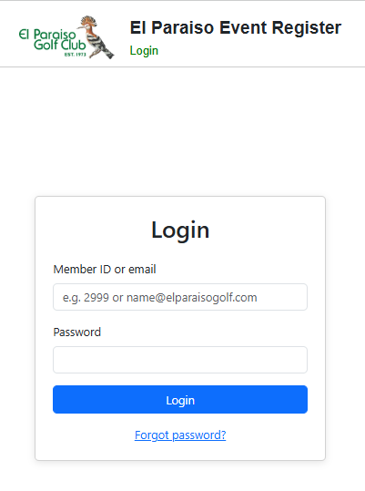
Enter your member id as both user and password
e.g.
user 111111
Password 111111
This will then take you to your start page
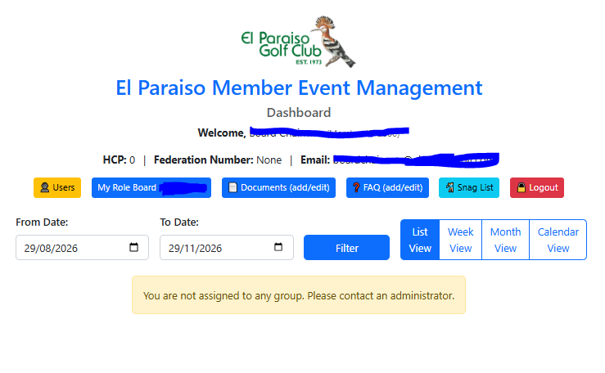
Then you can click on your role field and get a menu to access your “webmail” and shortcuts to your “workspace”.
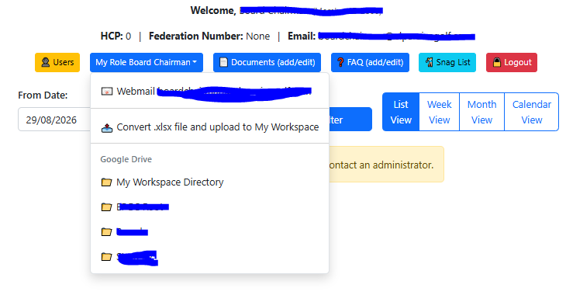
When you click on Webmail, you will see your login screen to access the email for your role.
The system is configured to forward all role emails to each volunteer's personal email for the duration of their tenure.
This ensures that all golf club-related emails are archived and stay available for the next person taking on this role.
When replying to an email, try to use the webmail functions in your role, ensuring that all email chains stay together and are available for your follower.
If you reply from your personal email, please try to CC: your role email address, i.e. myrole@elparaisogolf.com
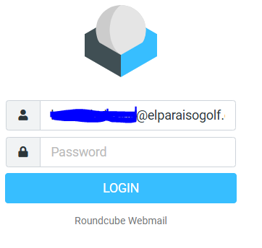
When clicking on My Workspace, it will take you to your role-dedicated workspace on the golf club Google Workspace, which will be regularly backed up.
Avoid Sending Attachments

You each have your own workspace directory.
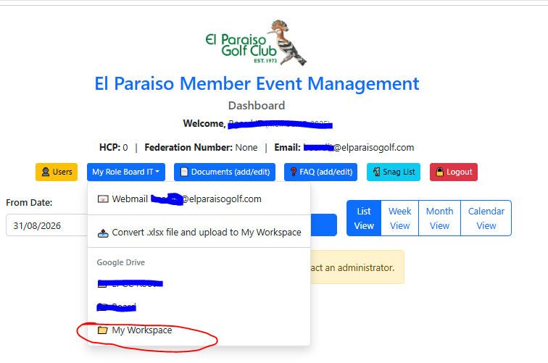
Contact Paula or Barry if you would like to add a shortcut to a different directory.
You can create a new directory or file, by clicking on the image below
You can upload documents by dragging from your laptop directly into this directory.
When you open the document, you can make it available for Editing, Suggesting or viewing. shared editing
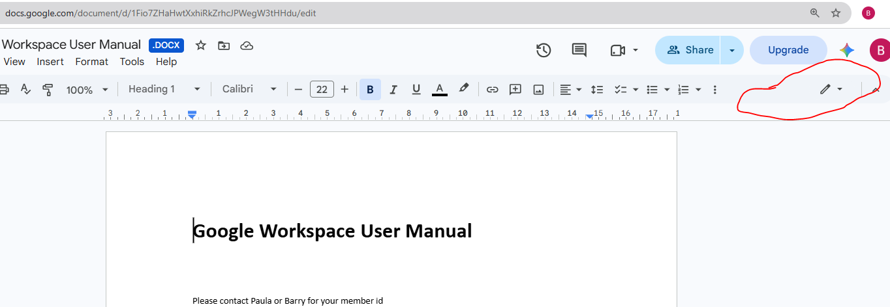
You will automatically be the author/owner of that document and can share read, comment or edit..
Highlighted in image below for any file:
1. 3 dot menu
2, Share
3. Share or Copy Link.
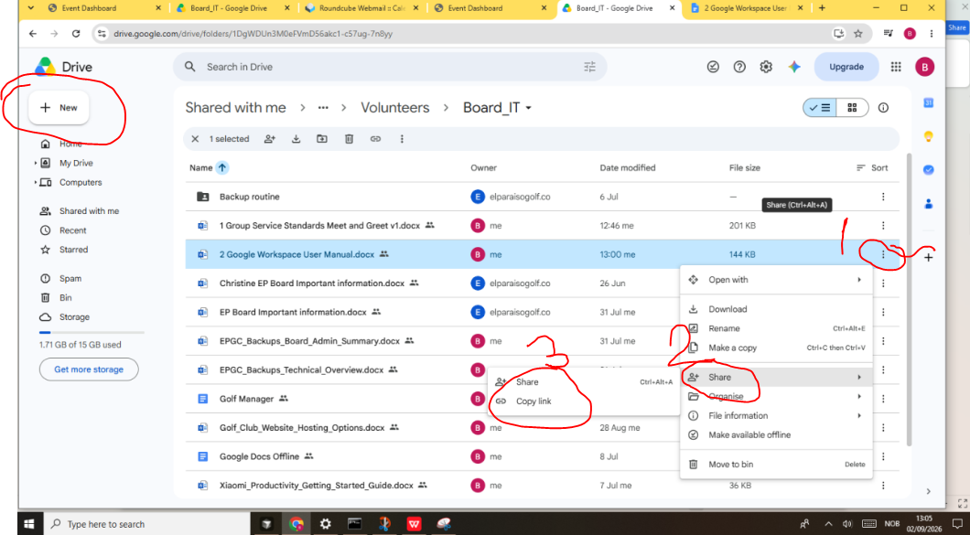
Click share, this will show you who has access to this file. Then you can enter an email of a colleague and give that person access to the document. The recipient will receive an email asking for access.
When pressed a message comes back to the author who then grants access!
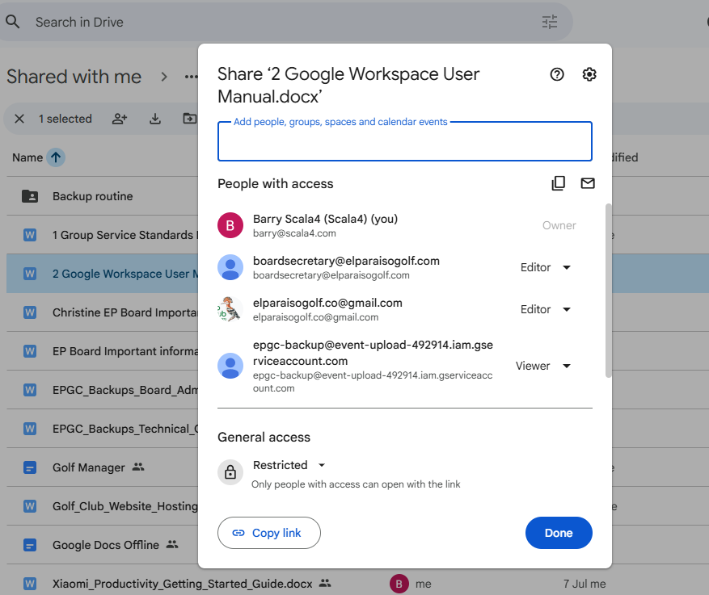
There are several layers of permission
You are the author.
1. Editor - Can edit the document freely
2. Commenter - Can make comments that will be available to all who can see the content and the author can then modify and/or accept the changes.
3. Viewer - Read only access
In the image above you can Click “Copy Link”
This link is now in your clipboard
To Copy link and send to your colleague:
Open your webmail and create a new email and click on the icon marked to enter HTML edit mode
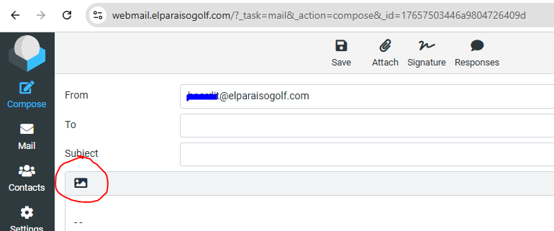
Mark the text and click on the icon 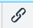
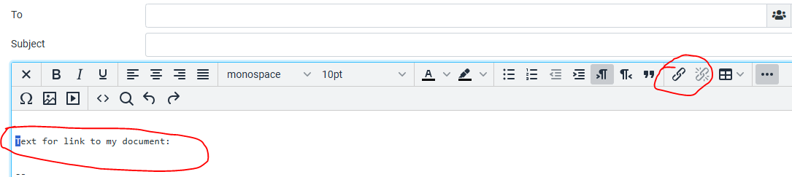

This will give you the following screen, then paste the link from the clipboard
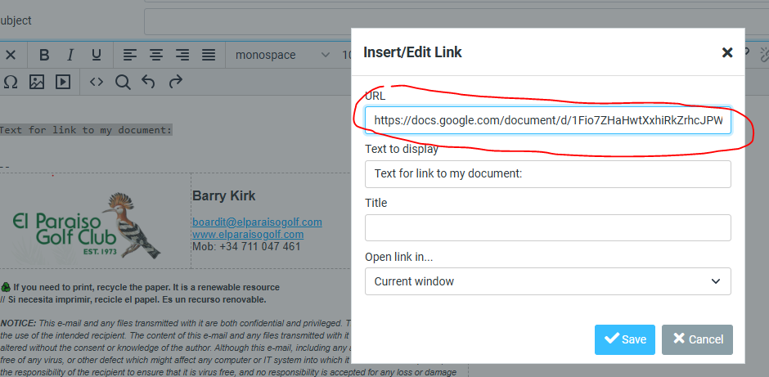
Press save.
Then you can add any accompanying content text as normal.
The email will be sent to the recipient(s) and they can each review and or edit based upon their permissions.
Google Sheets and Google Docs will now be the Golf Clubs standard. This will ensure that we do not have inconsistencies because people are using different editing tools!
If there are features that you are not able to do, please contact support.
It is imperative that we have a set of standard tools and processes

